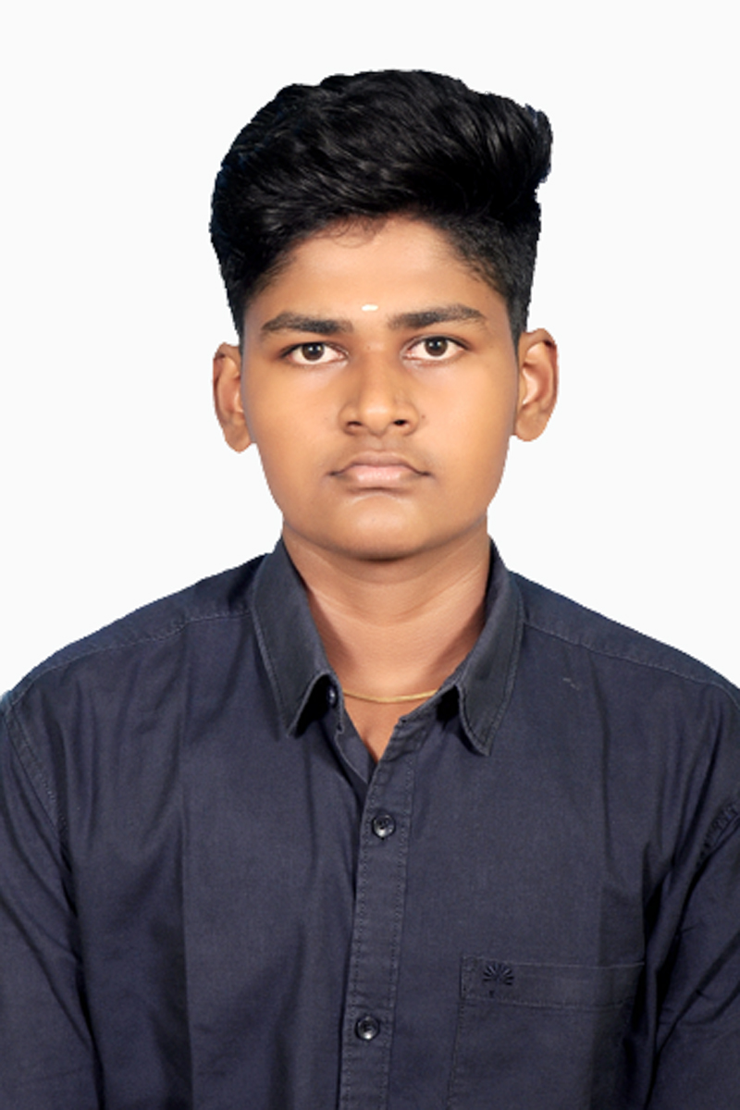ROSHAN S

## Mobile No : 9566522834

**Email :** [**roshans20082004@gmail.com**](mailto:roshans20082004@gmail.com)

**LinkedIn :** [**https://www.linkedin.com/in/roshan84/**](https://www.linkedin.com/in/roshan84/)

**Github** **:** [**https://github.com/spider-shan**](https://github.com/spider-shan)

# CAREER OBJECTIVE:

To kickstart my career by applying my programming skills and logical problem-solving abilities in a dynamic organization while continuously learning and contributing to innovative projects.

# ACADEMIC BACKGROUND:

|  |  |  |  |
| --- | --- | --- | --- |
| **Qualification** | **School / College** | **Year of**  **Passing** | **Percentage/CGPA** |
| B.E  (Computer Science) | Karpagam Academy of Higher Education | 2022 - 2026 | 7.67  *(Up to 6th semester) |
| HSC | Literacy Mission Matriculation Higher Secondary School | 2022 | 77.3 |
| SSLC | Literacy Mission Matriculation Higher Secondary School | 2020 | 64.8 |

**TECHNICAL SKILLS:**

* Programming Languages :Java, C
* Web Technology : HTML, CSS, JavaScript, React.js
* Tools & Platforms : Git, GitHub, VS Code, Eclipse
* Database Technology : SQL (Basic) – CRUD operations, Joins, and basic query writing

# PERSONAL SKILLS

* Logical Thinking
* Growth Mindset
* Creativity

# AREA OF INTEREST

* Problem Solving
* Web Development
* Algorithm

# ACHIEVEMENTS

* 400+ problems solved in Leet code Platform.
* 100+ problems solved in Geeks for Geeks.
* Top rank in Neocodeathon event.

# PROJECT

# Student Portal and Academic Management System (Team Project)

Time: [May 2025]

* Tech Stack: React.js, HTML/CSS, JavaScript, Local Storage
* Built a responsive student portal web application enabling students to sign up, log in, and access academic resources.
* Designed and implemented a dashboard with modules for Profile, Attendance, Marksheet, and College Introduction.
* Integrated authentication logic using local storage to manage user sessions securely on the client side.
* Created a dynamic navigation flow with proper route protection—users are redirected to the Home Page upon logout.
* Contributed to both front-end structure and team collaboration by managing routing, layout, and state management.

# PERSONAL DETAILS

Date of Birth: 20/08/2004

Father Name: Siva Kumar V

Address: 1/181 T-5 Kumaran Nagar, Paruvai, Palladam, Tiruppur - 641658

Hobbies: Gym, Listening Music

# DECLARATION

# I hereby declare that the information provided in this resume is true and accurate to the best of my knowledge and belief.

DATE:

PLACE: Coimbatore